**Output:**

#1

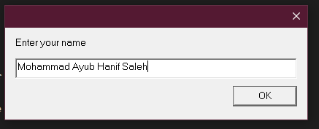

#2

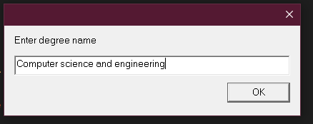

#3

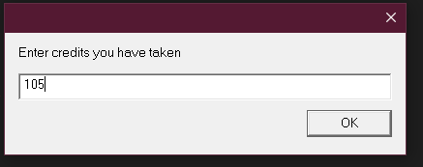

#4

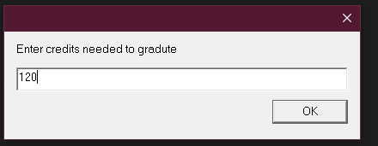

#5

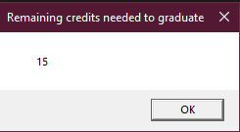

**Source Code:**

;

; Name : Mohammad Ayub Hanif Saleh

; class : CISP 310

; H.W : Assingment #3

; Professor : Al juboori

; Date : 2/19/2023

; Program : 8086 assembly program to take in basic information from a student gives and gives ; the total credits needed to get a degree.

.586

.MODEL FLAT

INCLUDE io.h ; header file for input/output

.STACK 4096

.DATA

number1 DWORD ?

number2 DWORD ?

number3 DWORD ?

number4 DWORD ?

prompt1 BYTE "Enter your name", 0

prompt2 BYTE "Enter degree name", 0

prompt3 BYTE "Enter credits you have taken", 0

prompt4 BYTE "Enter credits needed to gradute", 0

string BYTE 40 DUP (?)

resultLbl BYTE "Remaining credits needed to graduate", 0

sum BYTE 11 DUP (?), 0

.CODE

_MainProc PROC

input prompt1, string, 40 ; Get Name

atod string ; convert to integer

mov number1, eax ; store in memory

input prompt2, string, 40 ; second, DegreeName

atod string

mov number2, eax

input prompt3, string, 40 ; third, CreditsTaken

atod string

mov number3, eax

input prompt4, string, 40 ; fourth, TotalCreditsNeeded

atod string

mov number4, eax

mov eax, number4 ; first number to EAX

sub eax, number3 ; add second number

dtoa sum, eax ; convert to ASCII characters

output resultLbl, sum ; output label and sum

mov eax, 0 ; exit with return code 0

ret

_MainProc ENDP

END ; end of source code